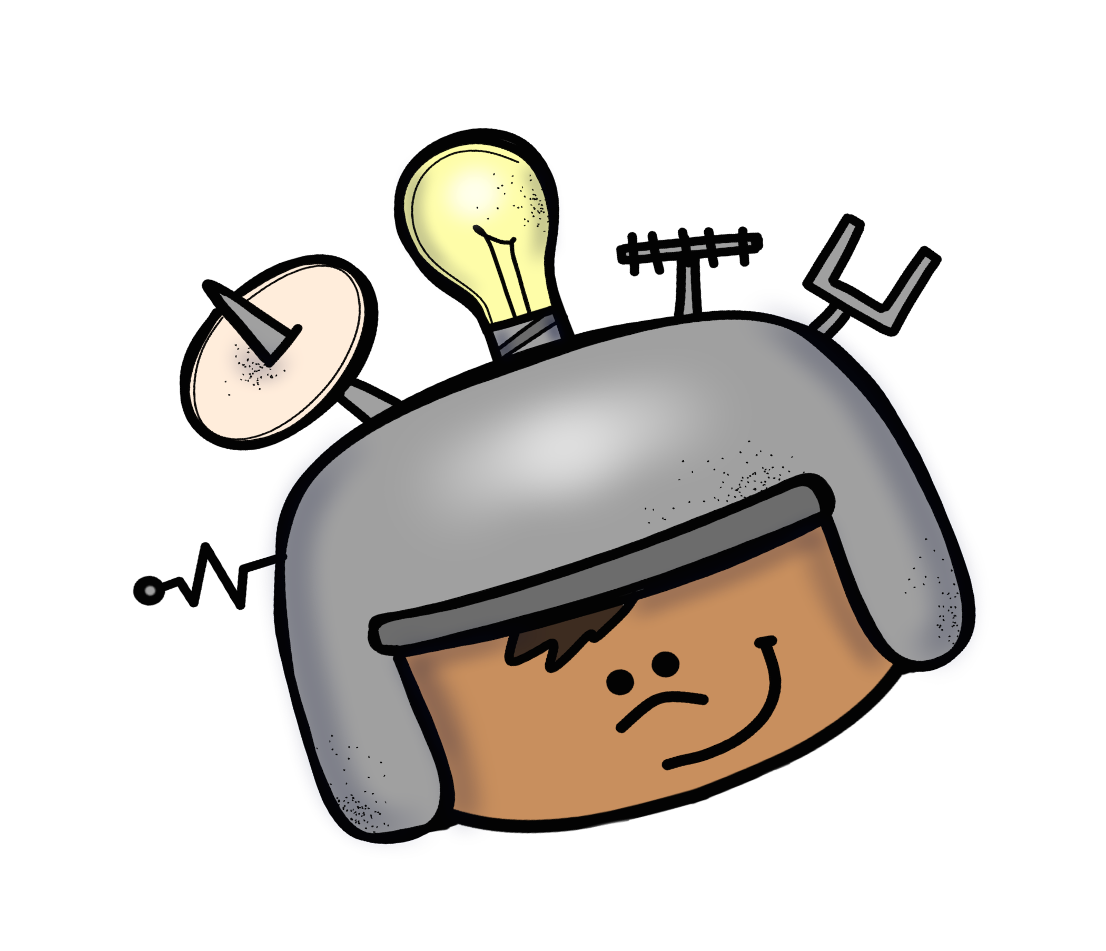
S.T.E.M.
Donation
Letter

This year our class will be participating in exciting STEM engineering projects that get students engaged in Science, Technology, Engineering, & Math. The students will be asked to be more hands-on during their learning. Students will also learn how to cooperate with others in order to achieve the end result. Some of the STEM units include, engineering an animal and habitat, building shade structures, designing and testing ramps, and composing 3D shapes and structures. We are in need of some help collecting materials for each STEM task. Here are some things we could use.

Used or Recycled Materials

• Legos
• Small boxes and/or Plastic
containers
• Cardboard and/or Cardboard
tubes
• Pie tins

*Make sure recycled items are
clean and dry!

New Craft Home & Office Supplies

• Coffee filters
• Modeling clay
• Paper plates
• Plastic cups
• Cotton balls
• Straws
• Clothespins
• Popsicle sticks
• Toothpicks
• Pipe cleaners
• Tape (painters, scotch)

